
AI-DRIVEN AIR QUALITY MONITORING AND PREDICTION SYSTEM
A CAPSTONE PROJECT REPORT
Submitted in partial fulfilment for the Course of
CSA1706 – Artificial Intelligence
to the award of the degree of
BACHELOR OF ENGINEERING
IN
COMPUTER SCIENCE AND ENGINEERING
Submitted by
A. Reddy Prasad (192472045)
N. Pramod (192572057)
P. Sai Lohith (192311286)
Under the Supervision of
Dr. Krishna Kumar
SIMATS ENGINEERING
Saveetha Institute of Medical and Technical Sciences
Chennai-602105
SEPTEMBER 2026

SIMATS ENGINEERING
Saveetha Institute of Medical and Technical Sciences
Chennai-602105
BONAFIDE CERTIFICATE
This is to certify that the Capstone Project entitled “AI-DRIVEN AIR QUALITY MONITORING AND PREDICTION SYSTEM” has been carried out by A. Reddy Prasad (192472045), N. Pramod (192572057), and P. Sai Lohith (192311286) under the supervision of Dr. Krishna Kumar and is submitted in partial fulfilment of the requirements for the current semester of the Bachelor of Engineering program in Computer Science and Engineering at Saveetha Institute of Medical and Technical Sciences, Chennai.

COURSE COORDINATOR COURSE FACULTY
Title / Name, Title / Name,
Designation Designation
Branch / Department Name Branch / Department Name
SIMATS Engineering, SIMATS Engineering,
SIMATS, Chennai – 602105. SIMATS, Chennai – 602105.

SIMATS ENGINEERING
Saveetha Institute of Medical and Technical Sciences
Chennai-602105
DECLARATION
We, A. Reddy Prasad (192472045), N. Pramod (192572057), and P. Sai Lohith (192311286) of the Computer Science and Engineering Department, SIMATS Engineering, Saveetha Institute of Medical and Technical Sciences, Chennai, hereby declare that the Capstone Project Work entitled “AI-DRIVEN AIR QUALITY MONITORING AND PREDICTION SYSTEM” is the result of our own bonafide efforts. To the best of our knowledge, the work presented herein is original, accurate, and has been carried out in accordance with the principles of engineering ethics and academic integrity.
All sources, references, data, and other materials used in the project have been appropriately acknowledged. We further declare that the data, results, analysis, and findings presented in this report have not been fabricated, falsified, or manipulated. Any external tools, software, datasets, computational resources, or AI-assisted tools used during the project have been appropriately disclosed.
We confirm that all applicable ethical, academic, institutional, and professional requirements have been duly followed throughout the planning, execution, analysis, and documentation of the project.

Place:
Date:

Signature of the Students with Names
A. Reddy Prasad (192472045)
N. Pramod (192572057)
P. Sai Lohith (192311286)

SIMATS ENGINEERING
Saveetha Institute of Medical and Technical Sciences
Chennai-602105
INDIVIDUAL CONTRIBUTION STATEMENT
(Mandatory for all team projects)
Student Name / Register No. | Specific Responsibilities | Design & Development Contribution | Testing & Analysis Contribution | Report Contribution | Approx. Contribution (%)
A. Reddy Prasad  192472045 | [To be completed by team] | [To be completed] | [To be completed] | [To be completed] | [__%]
N. Pramod  192572057 | [To be completed by team] | [To be completed] | [To be completed] | [To be completed] | [__%]
P. Sai Lohith  192311286 | [To be completed by team] | [To be completed] | [To be completed] | [To be completed] | [__%]
Total |  |  |  |  | 100%

ABSTRACT
Air pollution is a major environmental and public-health concern, particularly in urban and industrial regions. Air quality can change rapidly because of traffic, industrial activity, weather conditions, construction activity and other local factors. Conventional monitoring methods may provide measurements at limited locations and may not offer immediate predictive insight. This project proposes an AI-Driven Air Quality Monitoring and Prediction System that collects air-quality and environmental data, processes the data, calculates or uses Air Quality Index (AQI) information, and applies machine-learning techniques to predict future air-quality conditions.
The proposed system integrates data acquisition, preprocessing, feature engineering, machine-learning prediction and dashboard visualization. Sensor or public environmental data may include particulate matter (PM2.5 and PM10), temperature, humidity and gaseous pollutant measurements where available. After validation and cleaning, the data is transformed into features such as time, date, historical pollutant values and weather conditions. Prediction models such as Linear Regression, Random Forest, Gradient Boosting or time-series models can then be evaluated to estimate future AQI or pollutant concentrations.
The system provides a centralized dashboard for displaying current measurements, historical trends, predicted air quality and alerts. The implementation evidence in the original report includes a dashboard showing 5,000 active records and a displayed model accuracy of 95.4%, while the narrative report explicitly states that fixed accuracy should not be claimed without experimental evidence. The project demonstrates how artificial intelligence and data analytics can support environmental monitoring and informed decision-making. The proposed platform can be extended with real-time IoT sensors, cloud deployment, automated alerts, geospatial visualization and advanced deep-learning models.
Keywords: Air Quality Monitoring, Artificial Intelligence, AQI Prediction, Machine Learning, IoT, Environmental Analytics, PM2.5, PM10, Data Visualization, Predictive Analytics

TABLE OF CONTENTS

Sl.  No | Title | Page  No
i | CERTIFICATE FROM THE SUPERVISOR | ii
ii | DECLARATION BY THE CANDIDATE | iii
Iii | INDIVIDUAL CONTRIBUTION STATEMENT | iv
iv | ABSTRACT | v
v | LIST OF FIGURES | vi
vi | LIST OF TABLES | vii
vii | LIST OF ABBREVIATIONS | viii
1 | CHAPTER 1: Introduction
2 | CHAPTER 2: Literature Review
3 | CHAPTER 3: Engineering Design & Trade-offs, Sustainability,  Ethics, Safety, Risk & Security
4 | CHAPTER 4: Implementation, Testing & Results, Project  Management
5 | CHAPTER 5: Conclusion & Reflection
 | References
 | Appendices

LIST OF FIGURES
Figure No. | Figure Name | Page No.
Figure 4.1 | Module 1 and Module 2 implementation screens | [Update]
Figure 4.2 | Module 3 visualization dashboard | [Update]

LIST OF TABLES
Table No. | Table Name | Page No.
Table 1.1 | Project objectives | [Update]
Table 2.1 | Review of existing approaches | [Update]
Table 3.1 | Stakeholder / user requirements | [Update]
Table 3.2 | Functional and non-functional requirements | [Update]
Table 3.3 | Constraints and applicable standards | [Update]
Table 3.4 | Design specifications | [Update]
Table 3.5 | Alternative solution evaluation | [Update]
Table 3.6 | Trade-off analysis | [Update]
Table 3.7 | Sustainability, ethics, safety and security | [Update]
Table 3.8 | Risk register | [Update]
Table 4.1 | Tools / software / equipment and purpose | [Update]
Table 4.2 | Test plan and verification | [Update]
Table 4.3 | Results evidence available in the original report | [Update]
Table 4.4 | Objective achievement | [Update]
Table 4.5 | Project planning, roles and budget | [Update]

LIST OF ABBREVIATIONS / SYMBOLS
Symbol | Description | Unit
AI | Artificial Intelligence | —
AQI | Air Quality Index | Index
PM2.5 | Particulate Matter with aerodynamic diameter ≤ 2.5 µm | µg/m³
PM10 | Particulate Matter with aerodynamic diameter ≤ 10 µm | µg/m³
IoT | Internet of Things | —
MAE | Mean Absolute Error | Model metric
RMSE | Root Mean Square Error | Model metric
R² | Coefficient of Determination | Model metric

CHAPTER 1
INTRODUCTION AND ENGINEERING PROBLEM

1.1 Background
Air quality is influenced by particulate matter, gaseous pollutants, traffic emissions, industrial processes and meteorological conditions. Important indicators can include PM2.5, PM10, temperature, humidity and pollutant concentrations such as carbon monoxide or nitrogen dioxide when sensors or datasets are available. Because these factors vary over time, environmental data must be collected and analysed continuously to understand changing conditions.
Artificial intelligence and machine learning provide a practical way to analyse historical environmental patterns and estimate future conditions. By combining monitoring data with time and weather-related features, a prediction model can identify relationships that are difficult to observe through manual analysis alone. The proposed project integrates data collection, preprocessing, prediction and visualization into one decision-support system.

1.2 Need for the Project
The need for the project arises from the rapid variation of air-quality conditions and the limitations of systems that only display current readings. Environmental data may originate from different sensors or sources with different sampling intervals, units and data quality. An integrated monitoring and prediction platform can therefore provide current information together with historical trends and future estimates, while making data quality and uncertainty visible to users.

1.3 Problem Statement
How can AI and data analytics be used to collect, process, monitor and predict air-quality conditions in a reliable and understandable manner? The engineering problem involves changing environmental conditions, heterogeneous data sources, missing or noisy measurements, model-selection uncertainty and the need to communicate predictions without presenting them as certified measurements.

1.4 Project Aim
To develop an AI-driven air-quality monitoring and prediction system that integrates environmental data acquisition, preprocessing, machine-learning prediction and dashboard visualization for monitoring current conditions and estimating future air quality.

1.5 Project Objectives
- To collect air-quality and environmental data from sensors, APIs or datasets.
- To clean, validate and preprocess environmental measurements.
- To analyse historical pollutant and AQI patterns.
- To develop and evaluate machine-learning models for air-quality prediction.
- To identify periods of poor and improved air quality.
- To provide a dashboard for current, historical and predicted information.
- To support timely awareness and environmental decision-making.
- To design a scalable architecture for future real-time monitoring.

1.6 Scope
- PM2.5 and PM10 monitoring where data is available.
- Temperature and humidity analysis.
- Optional gaseous pollutant measurements.
- AQI or air-quality category analysis.
- Historical trend analysis and prediction.
- Data visualization and reporting.
- Potential real-time sensor or cloud integration.
The project is intended as a monitoring and decision-support system. Predictions are estimates and should not be treated as guaranteed measurements or as a replacement for certified regulatory monitoring.

1.7 Expected Engineering Outcome
The intended outcome is an integrated analytical platform that accepts environmental measurements, validates and preprocesses them, applies an AI-based prediction workflow, and presents current, historical and predicted air-quality information through a dashboard. The system is designed as a modular foundation that can later incorporate additional sensors, cloud services, geospatial visualization and advanced models.

CHAPTER 2
LITERATURE REVIEW AND EXISTING SOLUTIONS

2.1 Review Method
The original report identifies research papers, a World Health Organization air-quality guideline, and the general availability of environmental sensor and public air-quality datasets as supporting material. It does not document a formal database search protocol, inclusion/exclusion criteria or a systematic review procedure. Accordingly, the literature review in this reformatted report is limited to the sources already cited in the original report.

2.2 Review of Existing Work
The cited literature covers machine-learning approaches for AQI prediction, IoT and big-data-oriented air-pollution monitoring and forecasting, surveys of air-quality forecasting algorithms, and comparative studies involving machine learning and deep learning. The original report uses these sources to support the general suitability of data-driven prediction while emphasizing data quality, model validation and transparent communication of uncertainty.
Existing Approach | Advantages | Limitations identified in the report | Relevance to Proposed Work
Display / conventional monitoring | Provides current environmental measurements | Limited predictive insight; measurements may cover limited locations | Motivates integration of prediction with monitoring
Machine-learning AQI / pollutant prediction | Can model relationships in historical and weather-related data | Accuracy depends on dataset, sensor quality, features and testing | Provides candidate modelling approach
IoT-based monitoring | Supports continuous environmental data acquisition | Sensor noise, calibration and sampling differences can affect data quality | Supports future real-time sensor integration
Dashboard-based analytics | Makes current, historical and predicted information understandable | Visualizations can oversimplify data if uncertainty is not communicated | Forms the user-facing component of the proposed system

2.3 Comparative Analysis
The original report does not provide a numerical comparison of individual published systems. The comparison above therefore remains qualitative and is derived only from the problem description, stated methodology and cited source categories.

2.4 Research / Engineering Gap
The engineering gap identified by the project is the need to combine data acquisition, data-quality validation, predictive modelling and understandable dashboard communication in a single modular workflow. The report also highlights the need to avoid assuming that any one algorithm is universally accurate and to evaluate predictions against actual observations.

2.5 Proposed Contribution
The proposed contribution is an integrated monitoring-and-prediction architecture in which data acquisition, processing, AI prediction and visualization are separated into modules. This allows sensors, data sources and prediction models to be improved independently while keeping the system focused on reliable data handling and transparent presentation of predictions.

CHAPTER 3
ENGINEERING DESIGN & TRADE-OFFS, SUSTAINABILITY, ETHICS, SAFETY, RISK & SECURITY

3.1 Requirements

Stakeholder / User Requirements
Stakeholder | Requirement
Citizens and communities | Understandable current and predicted air-quality information.
Environmental authorities / municipal organizations | Air-quality information for awareness, planning and monitoring.
Researchers and data analysts | Historical data, trends and model outputs for analysis.
Industries and institutions | Monitoring of local environmental conditions.
Engineers / developers | Maintainable modular architecture and controlled system access.

Functional & Non-Functional Requirements
Requirement | Type | Measurable Target
Acquire environmental data | Functional | Accept sensor, dataset or API records.
Validate and clean data | Functional | Detect missing values, duplicates, invalid ranges and inconsistent timestamps.
Generate predictions | Functional | Produce AQI or pollutant predictions using a selected model.
Display trends and alerts | Functional | Show current values, historical trends, predicted values and configured alerts.
Maintain modularity | Non-Functional | Allow data sources, sensors and models to be improved independently.
Communicate uncertainty | Non-Functional | Clearly distinguish predictions from certified measurements.

3.2 Constraints & Applicable Standards
The original report states that modularity, separation of concerns, documentation, version control, input validation, error handling and repeatable model evaluation were applied. It does not identify a specific named technical standard or code. The new-format template requests specific standards; therefore, no unsupported standard is inserted here.
Standard / Code | Requirement | How Applied in This Project
Specific standard: Not stated in original report | Use only standards applicable to the implementation | To be completed if the team formally adopted a named standard.
Engineering practice: version control | Maintain reproducible project changes | Git is listed as the version-control technology.
Engineering practice: input validation | Detect invalid environmental records | Missing values, duplicates, invalid ranges, timestamps and units are checked.

3.3 Design Specifications
Parameter | Target / Requirement | Unit | Priority
Environmental data | Timestamp, location, PM2.5, PM10, temperature, humidity and optional gases | Various | High
Data validation | Missing values, duplicates, invalid ranges, timestamps and unit consistency checked | — | High
Prediction output | AQI or pollutant estimate with air-quality category | AQI / pollutant unit | High
Dashboard | Current, historical, predicted information and alerts | — | High
Scalability | Support future sensors / cloud integration | — | Medium

3.4 Alternative Solutions & Evaluation
Alternative 1: Monitoring-only dashboard. This approach focuses on displaying current and historical measurements without a predictive model.
Alternative 2: Integrated AI monitoring and prediction. This approach combines acquisition, preprocessing, prediction and dashboard visualization.
Alternative 3: Advanced real-time IoT/cloud platform. This approach extends the integrated system with denser sensors and scalable cloud infrastructure; the original report identifies these as future extensions rather than a fully documented current implementation.
Criterion | Weight | Alternative 1 | Alternative 2 | Alternative 3
Performance | [To be assigned] | Medium | High | High
Cost | [To be assigned] | Low | Medium | High
Safety | [To be assigned] | Medium | High | High
Sustainability | [To be assigned] | Medium | Medium | Medium
Reliability | [To be assigned] | Medium | High | Depends on deployment

Note: The original report does not provide numerical weights or a formal scoring matrix. The qualitative ratings above are a format conversion based on the described system characteristics and should be replaced by the team's documented evaluation if available.

3.5 Selected Design & Detailed Design
The integrated monitoring-and-prediction architecture is selected because it directly addresses both sides of the stated problem: current monitoring and future estimation. The modular design allows sensors, data sources and prediction models to be improved independently.
System flow: Data Sources → Data Acquisition → Cleaning and Validation → Structured Storage → Feature Engineering → AI Prediction Model → AQI / Air-Quality Analysis → Dashboard and Alerts.
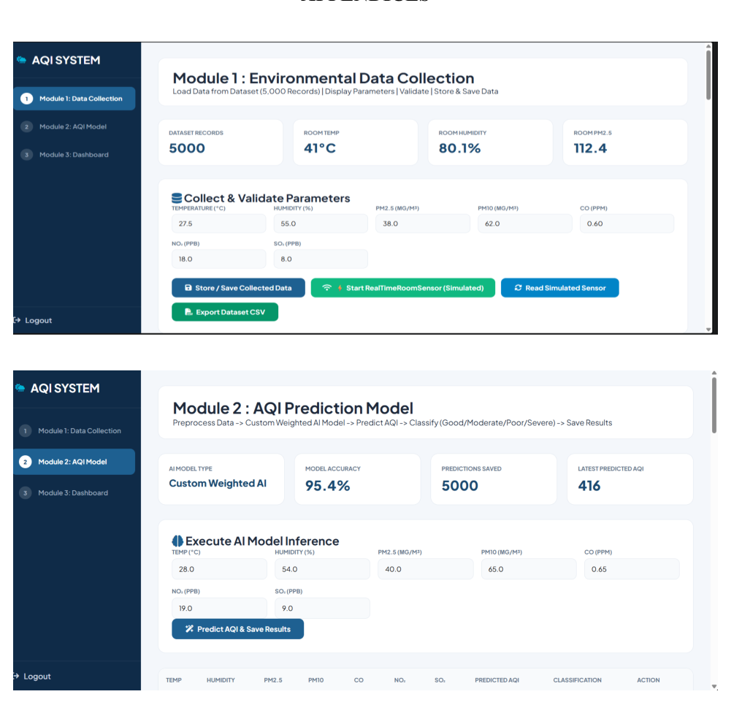
Figure 3.1 Implementation evidence for data collection and AI prediction modules
Key engineering calculations: The original report states that MAE, RMSE and R² may be used for regression or forecasting evaluation, but it does not provide calculation tables or derivations. Lengthy derivations should therefore be added by the team in Appendix A if required.
Systems approach: The data-acquisition module supplies environmental measurements to the processing stage. Cleaning and validation convert heterogeneous inputs into structured data suitable for feature engineering. The prediction module uses historical and environmental features to generate AQI or pollutant estimates. The dashboard then combines current measurements, trends, predictions and alerts for decision support.

3.6 Trade-off Analysis
Design Decision | Alternative Considered | Benefit | Disadvantage | Final Decision & Justification
Integrated monitoring + prediction | Monitoring-only dashboard | Adds predictive insight | Requires model validation | Selected because the problem explicitly includes future prediction.
Modular architecture | Single tightly coupled application | Independent improvement of sensors, data sources and models | Requires clear interfaces | Selected because the original report emphasizes modularity.
Candidate-model comparison | Assume one algorithm is best | Reduces risk of unsuitable model choice | Adds evaluation effort | Selected because the report recommends comparing candidate methods.

3.7 Sustainability, Ethics, Safety, Risk & Security
Domain | Consideration | Evidence Evaluated | Impact on Final Decision
Sustainability | Prefer extensible architecture and avoid unnecessary complexity | Modular design; future cloud/IoT extension | Supports reusable architecture and staged expansion.
Ethics | Data minimization and responsible communication | Original report's ethical principles | Predictions are presented as estimates, not certified measurements.
Health & Safety | Avoid unsupported health claims or misleading alerts | Original report's safety/communication guidance | Alerts should be threshold-based and clearly communicated.
Security | Protect stored data and control administration access | Original report's security controls | Access control and responsible handling are part of the design.

Risk Register
Risk | Likelihood | Severity | Risk Level | Mitigation | Residual Risk
Missing / inconsistent measurements | Medium | Medium | Medium | Validation and cleaning | Medium
Sensor noise / calibration limitations | Medium | High | High | Calibration and sensor-health checks | Medium
Limited historical data | Medium | High | High | Use adequate historical coverage; compare with baseline | Medium
Overfitting / poor generalization | Medium | High | High | Compare models and evaluate on observations | Medium
Misleading interpretation of predictions | Low-Medium | High | Medium-High | Display uncertainty and distinguish estimates from certified measurements | Low-Medium

CHAPTER 4
IMPLEMENTATION, TESTING & RESULTS, PROJECT MANAGEMENT

4.1 Development Approach & Resources
The methodology consists of data acquisition, preprocessing, exploratory analysis, feature engineering, model training, evaluation, prediction and dashboard development. Raw measurements are validated for missing values, duplicates, invalid ranges and inconsistent timestamps. Relevant features are then used to train candidate models, which are compared using suitable evaluation metrics. The selected model produces predictions that are presented with historical and current information through the dashboard.
Resource Category | Resource Used
Data sources | IoT sensors, public datasets or approved APIs
Environmental fields | Timestamp, location, PM2.5, PM10, temperature, humidity and optional gaseous pollutants
Development | Python, VS Code / Jupyter Notebook
Data processing | Pandas, NumPy
Machine learning | Scikit-learn; TensorFlow / Keras listed as optional
Database | MySQL / PostgreSQL
Visualization | Power BI / Streamlit / Python
Version control | Git
Deployment | Cloud or local server

4.2 Software Implementation & Modern Tools Used
The implementation is organized into four modules: data acquisition, data processing, AI prediction, and dashboard/alerts. The original report also lists database, IoT integration, visualization and development tools.
Tool / Software / Equipment | Purpose | Stage Used
Python | Core programming and analytics | Development / modelling
Pandas, NumPy | Data cleaning and numerical processing | Preprocessing
Scikit-learn | Machine-learning model development | Prediction
TensorFlow / Keras | Optional deep-learning models | Future / optional modelling
MySQL / PostgreSQL | Structured data storage | Storage
ESP32 / compatible sensor gateway | IoT data acquisition | Current/future integration
Power BI / Streamlit / Python | Visualization and dashboard | Presentation
VS Code / Jupyter Notebook | Development and experimentation | Development
Git | Version control | Development

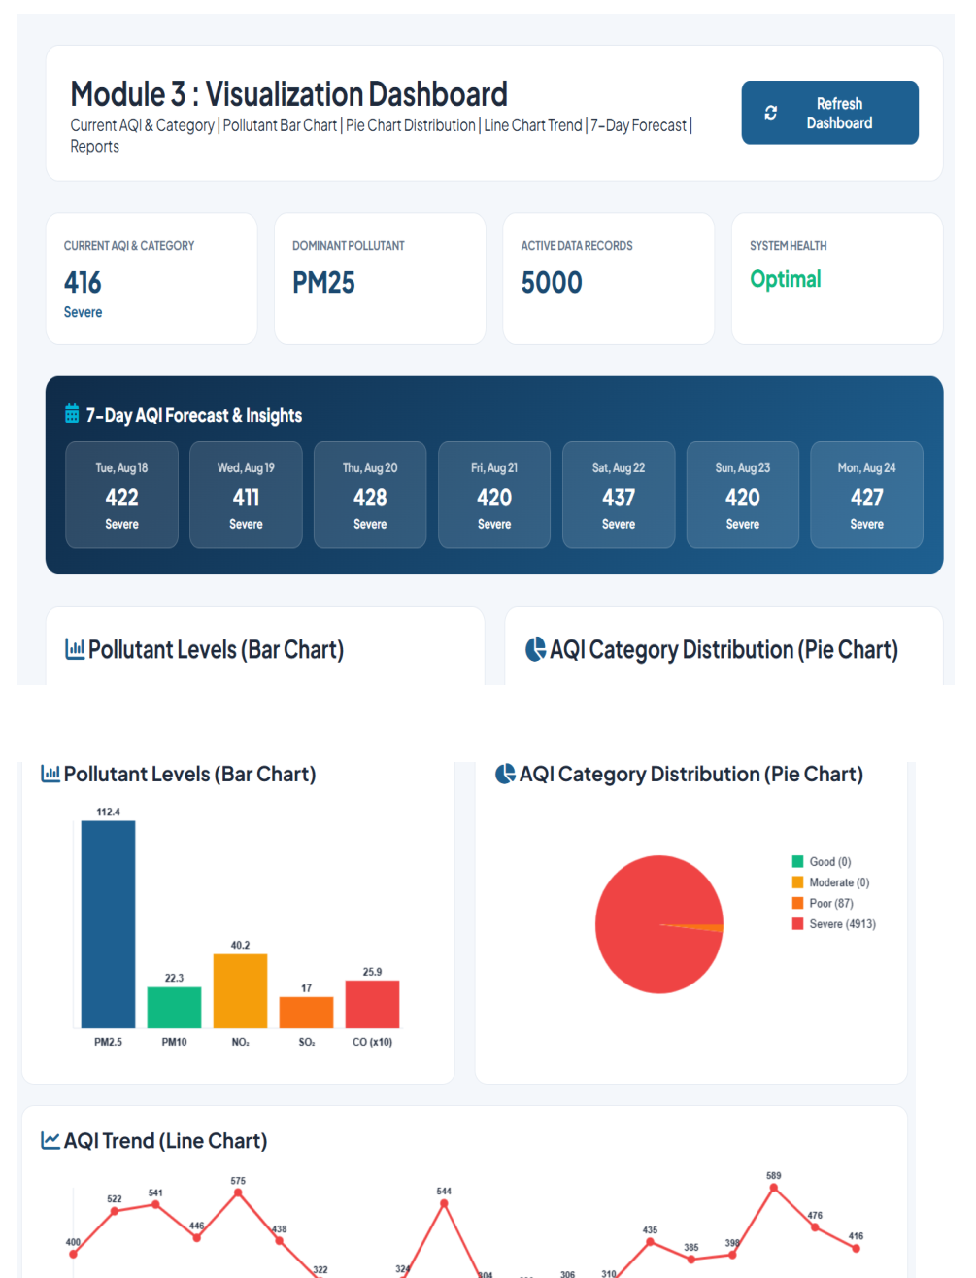
Figure 4.1 Visualization dashboard implementation evidence from the original report

4.3 Test Plan & Verification
The original report states that evaluation should include data quality, model accuracy and usability measures. It recommends MAE, RMSE and R² for regression or forecasting where appropriate and requires comparison with a simple baseline such as persistence or historical average.
Requirement | Test Method | Acceptance Criterion
Data completeness and validity | Check missing values, duplicates, invalid ranges, timestamps and units | Invalid records detected and handled before modelling
Prediction performance | Compare candidate models using MAE, RMSE and R² where appropriate | Selected model performs acceptably against baseline
Dashboard functionality | Verify current values, historical trends, predicted values and categories | Required views are displayed correctly
Alert functionality | Test configured thresholds | Alert is generated when threshold is exceeded

Specification | Required Value | Achieved Value | Status (Pass/Fail)
Dataset records | Adequate validated records | 5,000 records shown in implementation evidence | [To be verified]
Displayed model accuracy | Model-specific experimental target | 95.4% displayed in screenshot | [To be verified]
Latest predicted AQI | Generated prediction | 416 displayed | [To be verified]

4.4 Results
The implementation screenshots in the original report provide concrete visual evidence of the three-module workflow. The Module 1 screen shows environmental data collection with 5,000 dataset records and fields including temperature, humidity, PM2.5, PM10, CO, NO and SO2. The Module 2 screen shows an AI prediction interface with a displayed model accuracy of 95.4%, 5,000 predictions saved and a latest predicted AQI of 416.
The Module 3 dashboard shows a current AQI of 416 classified as Severe, PM25 as the dominant pollutant, 5,000 active data records and system health marked Optimal. It also displays a seven-day AQI forecast and pollutant/AQI trend visualizations.
Result Evidence | Value / Observation | Source in Original Report
Dataset records | 5,000 | Module 1 screenshot
Displayed model accuracy | 95.4% | Module 2 screenshot
Predictions saved | 5,000 | Module 2 screenshot
Latest predicted AQI | 416 | Module 2 screenshot
Current AQI category | 416, Severe | Module 3 dashboard screenshot
Dominant pollutant | PM25 | Module 3 dashboard screenshot
System health | Optimal | Module 3 dashboard screenshot
Seven-day forecast | 422, 411, 428, 420, 437, 420, 427 | Module 3 dashboard screenshot

Important qualification: the original narrative report explicitly states that actual numerical performance depends on the dataset, sensor quality, feature availability and testing procedure and does not claim a fixed accuracy without experimental evidence. Therefore, the 95.4% value is reported here as displayed implementation evidence, not independently validated performance.

4.5 Data Analysis & Engineering Judgment
The engineering judgment in the original report is that data quality must be addressed before model complexity. Missing or inconsistent measurements, sensor noise, calibration limitations, different sampling intervals, limited historical data, weather/local-event variation and overfitting can all affect prediction quality. Consequently, the recommended workflow is to validate and clean data first, compare candidate models, test against observations and communicate uncertainty and data freshness.
The dashboard evidence shows a severe current AQI classification and a seven-day forecast remaining in the severe category. This demonstrates the intended end-to-end presentation of prediction results, but the report does not provide enough experimental detail to establish statistical confidence in those forecasts.

4.6 Comparison with Existing Solutions & Achievement of Objectives
Objective | Evidence | Achievement (Fully / Partially / Not Achieved)
Collect environmental data | Module 1 data collection screen and 5,000 records | Partially / To be verified
Clean, validate and preprocess data | Processing workflow described; detailed validation logs not provided | Partially / To be verified
Analyse historical AQI patterns | Dashboard trend and category charts | Partially / To be verified
Develop and evaluate ML models | Module 2 prediction screen; 95.4% displayed accuracy | Partially / To be verified
Identify poor/improved air-quality periods | AQI categories and seven-day forecast shown | Partially / To be verified
Provide dashboard | Module 3 visualization dashboard | Partially / To be verified
Support awareness and decision-making | Dashboard presents current and forecast information | Partially / To be verified
Design scalable architecture | Modular architecture and future IoT/cloud extensions described | Partially / To be verified

4.7 Strengths & Limitations
Strengths:
- Integrates data acquisition, preprocessing, AI prediction and dashboard visualization.
- Uses a modular architecture that permits independent improvement of sensors, data sources and models.
- Includes data-quality validation concepts and model-comparison guidance.
- Provides current, historical and predicted air-quality information in one dashboard.
Limitations:
- The original report does not provide detailed experimental datasets, train/test splits or reproducible model configurations.
- The 95.4% accuracy shown in the interface is not accompanied by sufficient experimental evidence in the report to independently validate it.
- Sensor calibration, noise, sampling differences and limited historical data may affect performance.
- Predictions are estimates and are not replacements for certified regulatory monitoring.

4.8 Project Planning, Roles & Budget
The original report does not include a Gantt chart, milestone schedule, student-wise responsibility allocation, or project cost figures. The new-format structure is provided below so the team can complete these items without changing the technical content.
Student | Assigned Responsibility | Actual Contribution
A. Reddy Prasad (192472045) | [To be completed] | [To be completed]
N. Pramod (192572057) | [To be completed] | [To be completed]
P. Sai Lohith (192311286) | [To be completed] | [To be completed]

CHAPTER 5
CONCLUSION & REFLECTION

5.1 Conclusion
The AI-Driven Air Quality Monitoring and Prediction System provides an integrated approach to environmental data analysis. The proposed system collects data, validates and preprocesses measurements, applies AI models and presents results through a dashboard. The modular architecture supports future improvements without requiring the complete system to be redesigned.
The implementation evidence demonstrates the intended workflow from environmental data collection through AI prediction to dashboard visualization. The system is positioned as a monitoring and decision-support platform, while the original report appropriately cautions that predictions should not be treated as guaranteed measurements or as a replacement for certified regulatory monitoring.

5.2 Future Work
- Add more real-time sensors and locations.
- Incorporate richer weather information.
- Use automated sensor-health checks.
- Apply advanced time-series or deep-learning models where justified.
- Add notification and alert services.
- Deploy the system on scalable cloud infrastructure.
- Develop geospatial visualization and heat maps.
- Introduce continuous model monitoring and retraining.
- Integrate the platform with broader smart-city environmental systems.

5.3 Professional Learning & Individual Reflection

New Knowledge Acquired
- Environmental data analytics and air-quality monitoring concepts.
- Machine learning and time-series concepts for prediction.
- Data preprocessing, feature engineering and predictive evaluation.
- Dashboard-based communication of environmental information.

Engineering & Professional Skills Developed
- Python programming and data processing.
- Machine-learning model development and comparison.
- Database handling and IoT-oriented data acquisition concepts.
- Data visualization and dashboard development.
- Modular design, maintainability, documentation, testing, version control and error handling.

Individual Reflection
A. Reddy Prasad (192472045): [Add 4–5 lines describing the most difficult engineering problem encountered, a personal engineering decision and its evidence, independently acquired knowledge, and what would be redesigned if the project were repeated.]
N. Pramod (192572057): [Add 4–5 lines describing the most difficult engineering problem encountered, a personal engineering decision and its evidence, independently acquired knowledge, and what would be redesigned if the project were repeated.]
P. Sai Lohith (192311286): [Add 4–5 lines describing the most difficult engineering problem encountered, a personal engineering decision and its evidence, independently acquired knowledge, and what would be redesigned if the project were repeated.]

5.4 Overall Reflection
The project strengthened technical, analytical and engineering skills by requiring an end-to-end solution from raw data to user-facing results. It also highlighted the importance of validation, uncertainty, maintainability and ethical responsibility in AI-based systems. The experience reinforces that a sophisticated algorithm cannot compensate for unreliable data and that practical environmental analytics requires sensing, data management, machine learning, software engineering and responsible communication.

REFERENCES
[1] Bhattacharya, S., & Shahnawaz, S. (2021). Using machine learning to predict air quality index in New Delhi. arXiv preprint arXiv:2112.05753.
[2] Gangwar, A., Singh, S., Mishra, R., & Prakash, S. (2023). The state-of-the-art in air pollution monitoring and forecasting systems using IoT, big data, and machine learning. arXiv preprint arXiv:2304.09574.
[3] World Health Organization. (2021). WHO global air quality guidelines: Particulate matter (PM2.5 and PM10), ozone, nitrogen dioxide, sulphur dioxide.
[4] Masud, K. I., Unnam, V. S. R., & Ali, S. (2026). Benchmarking scientific machine learning models for air quality data. arXiv preprint arXiv:2603.21039.
[5] Rybarczyk, Y., & Zalakeviciute, R. (2022). Machine learning algorithms for air quality forecasting: A survey. Artificial Intelligence Review.
[6] Sharma, A., Kumar, P., & Singh, R. (2023). Air quality prediction by machine learning models: A predictive study on the Indian coastal city of Visakhapatnam. Environmental Research.
[7] Han, J., Zhang, W., Liu, H., & Xiong, H. (2023). Machine learning for urban air quality analytics: A survey. arXiv preprint.
[8] Xu, T., Tian, Y., Cai, X., Wu, C., & Mian, Z. (2025). Air quality forecasting and rating based on machine learning algorithm and cumulative logit model: An empirical study for Lanzhou city of China. Environment, Development and Sustainability.
[9] Bhatt, D., Goswami, S., Verma, G., & Pandey, B. K. (2026). Air Quality Index prediction using machine learning and deep learning: A comparative analysis of Dehradun and Kashipur in Uttarakhand, India. Advances in Research.
[10] Kher, V. I. (2026). Air Quality Index prediction for Indian cities using machine learning: A comparative study of Random Forest and XGBoost on Delhi, Noida, and Faridabad. International Journal for Research in Applied Science & Engineering Technology.
[11] Mukendi, M. C., & Choi, H. (2024). Air quality forecasting using machine learning: A global perspective with relevance to low-resource settings. arXiv preprint.
[12] Xu, T., Tian, Y., Cai, X., Wu, C., & Mian, Z. (2025). Machine learning-based forecasting and rating of air quality using major pollutant indicators. Environment, Development and Sustainability.
[13] Explainable forecasting of air quality index using a hybrid Random Forest and ARIMA model. (2025). MethodsX, 15, 103517.

CHAPTER A
APPENDICES

Appendix A – Detailed Calculations
The original report states that MAE, RMSE and R² may be used for regression or forecasting evaluation, but it does not contain detailed derivations. Insert the project-specific equations, sample calculations and model-evaluation outputs here if required.

Appendix B – Engineering Drawings / Screenshots


Figure B.1 Module 1: Environmental Data Collection and Module 2: AQI Prediction Model

Figure B.2 Module 3: Visualization Dashboard

Appendix C – Source Code / Code Repository Information
The original report does not provide a repository URL or complete source code. The approved repository information and only essential code excerpts should be added here, consistent with the new-format guidance.

